Overview: Looping of audio samples

Looping
The looping of an audio file is the process of continuously repeating a specific, segment of audio. In digital audio, this process involves re-reading data from a specific memory address (the start point) once the playback reaches the end address. The physics behind this involves managing digital signal waves to ensure that the end of one playback cycle seamlessly connects to the beginning of the next, avoiding auditory artifacts like pops or clicks. After playing the whole range of samples, the pointer is re-initialized to the loop start sample and it gets incremented .This process is repeated until key release. It is crucial to select a proper loop start point to avoid noise issues. This document contains insights on looping process, potential problems and solutions in development of efficient looping.
For a loop to sound continuous, the waveform at the loop's endpoint must match the phase and amplitude of the waveform at the start point. If the wave is not continuous (e.g., if it jumps from a high amplitude to a low one), the abrupt change in air pressure causes an audible "click".

Terms in looping
Few terms which are important to understand the looping have been mentioned below.

Zero-Crossing Points
Ideal loops often start and end at "zero-crossing" points, where the audio signal passes through the center line (representing zero amplitude or silence). This minimizes the abrupt change in pressure at the transition point.

Crossfading
To avoid discontinuities, technical, a short crossfade is often applied at the junction, blending the end of the file into the beginning.

Looping data value
Looping data is the first value loaded to DAC for starting the loop. This value is written to DAC channel as soon as sample table reaches end and enter looping phase. This value was chosen through lot of experiments, to get clean, noiseless and continuous looping sound.

Loop start address
The start address from where loop starts.

Loop end address
The end address from where loop end (which has last sample of loop).
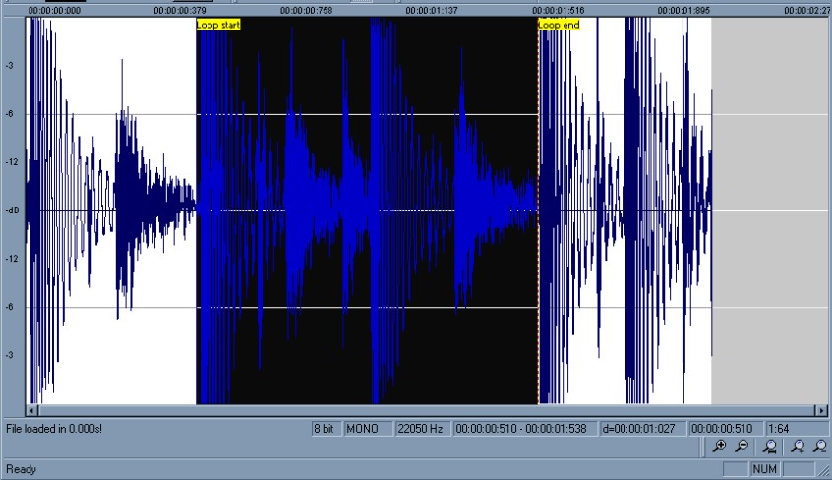

Methods to achieve proper looping

Using looping data
In some scenarios of noise in looping, arriving at proper looping data contributes to smooth looping.

Experiment to find proper looping data
At the beginning of the looping in sample output ISR, a free port line is toggled; using oscilloscope the DAC output waveform and port line toggle is viewed together; the point of waveform at the instant of the toggle is analyzed to check if there is smooth transition during looping; if there is no smooth transition, the first sample is modified to achieve smooth transition. This method is sometimes useful to achieve smooth and continuous looping. Sometimes there is discontinuity of sound during looping (motor like sound) even with smooth transition in the beginning of the looping.

Using end of file marker
End of the sample is identified by checking if DAC value is 0xFFFF. Place the end of the file marker (0xFFFF) next to a sample that is closer to middle value (2048 or 0x800).This can also provide you with smooth looping.

Using multiple cycles for looping
Choose the loop start address such that the starting point is few cycles (more than 20 cycles) behind the end point. The starting point should coincide with that part of the wave cycle so that there is continuity between last sample and the first sample of the loop start address.

Experiment to find proper loop start address
Use a delta variable and add it to the loop start address mentioned above. Vary this delta variable with the turn of the knob. (Use encoder).Press the note key continuously and hear the looping sound intently. If there is discontinuity turn the knob clockwise and anti-clockwise. At one particular point of delta, proper looping can be achieved.

Using re-sampled wave
Mostly, by using one or more of the above steps looping is achieved. If none of the above works, the wave file is resampled at a frequency few hertz less than the original sample frequency.
E.g. A wave file originally sampled at 22050 Hz can be re-sampled to 22040 Hz and then the above steps can be repeated. The logic behind this method is several times, the no. of samples in a single cycle of the recordered wave does not have integral no. of samples.
But we can loop back only by integral no. of samples ( e.g. - we can go back by 1000 samples not 1000.5 samples), and perfect looping is not achieved. But when the wave is re-sampled, there are chances that no. of samples comes closer to an integral number, and proper looping sound too is achieved. Many times, this method works and sometimes this does not work. Re-sampling can be done in Goldwave or any audio software.

